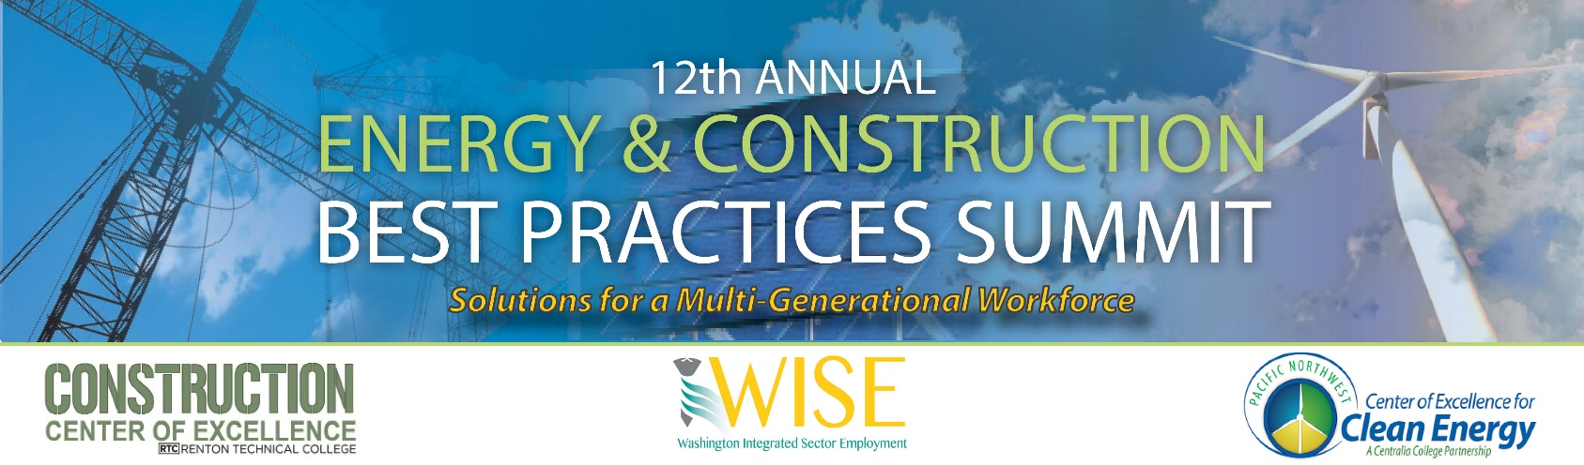

June 1 & 2
Centralia College

Please join us as a sponsor of one of the premier energy and construction workforce conferences in the Northwest, the 12th Annual Energy & Construction Best Practices Summit! At this event, we will focus on the most pressing issues and challenges which are facing our workforce. Features of this year’s summit:
- Nearly 200 industry, organized labor, workforce, economic development, and education representatives will attend. They represent the largest organizations in the Northwest.
- A strong line-up of industry experts will be presenters and panelists.
- An opportunity for one-on-one interaction in a collegial atmosphere with your customers and supporters.

An INDOOR Vendor Pavilion – with scheduled walk-throughs and networking breaks for our guests with public access (no overnight security).

We invite your organization to join us at one of the following support levels:

 | Bronze | Silver | Gold | Platinum
Contribution | $250 | $500 | $750 | $1,000
Vendor Pavilion | 1 Table | 1 Table | 2 Tables | Location choice +  unlimited space
Lunch  Presentations | N/A | N/A | N/A | Day 1-Lunch
Printed Program | Name Listing | Logo Listing | Logo Listing | ½ Page Ad
Meal Sponsor  Listing | N/A | Afternoon Snack | Breakfast | Lunch
Additional signage | signage | signage | signage and PPT  slide | signage and PPT  slide
Presentation Scroll | Name Only | Name Only | Logo+ Name | Logo+ Name

For more information please contact:

Sean Bagsby Kristi Grassman
seanbagsby@ibew46.com grassman2012@comcast.net
(425) 351-8911 (253) 561-9407

Sponsorship Terms and Conditions
The 12th Annual Energy & Construction Best Practices Summit will be June 1-2, 2017 at Centralia College: 600 Centralia College Blvd., Centralia, WA 98531
EXHIBITOR SET-UP: Please be set-up and ready for guests by 10:30 am, Thursday, June 1st.
EXHIBITOR TEAR DOWN: June 2nd, after 1pm and completed by 3pm.
- Booth Needs should be stated on Event Sponsor and Exhibitor Information form. Tables are standard 6’ in length. Gold/Platinum Sponsors may request a double table, or request space for a standalone display. Under no conditions may a vendor use more space than is assigned without permission of the event director.
- Electric outlets are limited and available upon request. The conference will do everything to meet power and other considerations but there are no guarantees of availability. Vendor must supply extension cord. Any equipment requests will be honored on an as-available basis and may incur additional charges.
- The conference agenda will include dedicated time for attendees to visit with exhibitors. All meals provided at the conference are open to vendors.
- Platinum Sponsors are encouraged to make five-minute presentations during lunch.
- Payment may be made to the Centralia College Fund – CoE Summit and may be made by check or credit card.
In-Kind contributions will not count towards total sponsorship levels. Refunds will only be issued for cancellations received by May 15, 2017.
- Logos used in any promotional display either online or in print must be provided by the sponsor and permission granted for replication of the logo or image. Please provide a print quality jpeg image. The summit will not use any logos without express permission. Logos are due by May 5th.
- Vendors must all register for the conference via the online website in addition to the sponsorship application. Visit http://cleanenergyexcellence.org/summit to register. There is no additional fee.
- Unless otherwise agreed to in advance, no other benefits shall be conferred upon sponsors not specifically enumerated in the agreement. In the event of a dispute or disagreement between: the sponsor and the Event Hosts or between two or more sponsors; all interpretations of the rules governing the sponsorship contract, actions, or decisions concerning this dispute or disagreement by the Event Director intended to resolve the dispute or disagreement shall be binding on the sponsor.
- The distribution of samples, souvenirs, and publications, etc., may be conducted by the sponsor. The sponsor shall conduct and operate its sponsorship (if a physical element exits) so as not to annoy, endanger or interfere with the rights of other exhibitors, sponsors and attendees. Any practice resulting in complaints from any other exhibitor, sponsor or any attendee, who in the opinion of Event Director interferes with the rights others or exposes them to annoyance or danger, may be prohibited by Event Director.
- Each party to this agreement shall be responsible for its own acts and/or omissions and those of its officers, employees and agents. No party to this agreement shall be responsible for the acts and/or omissions of entities or individuals not a party to this agreement.

I agree to all of the terms and conditions on the sponsorship agreement.

____________________________________________________ ______________________
Signature Date
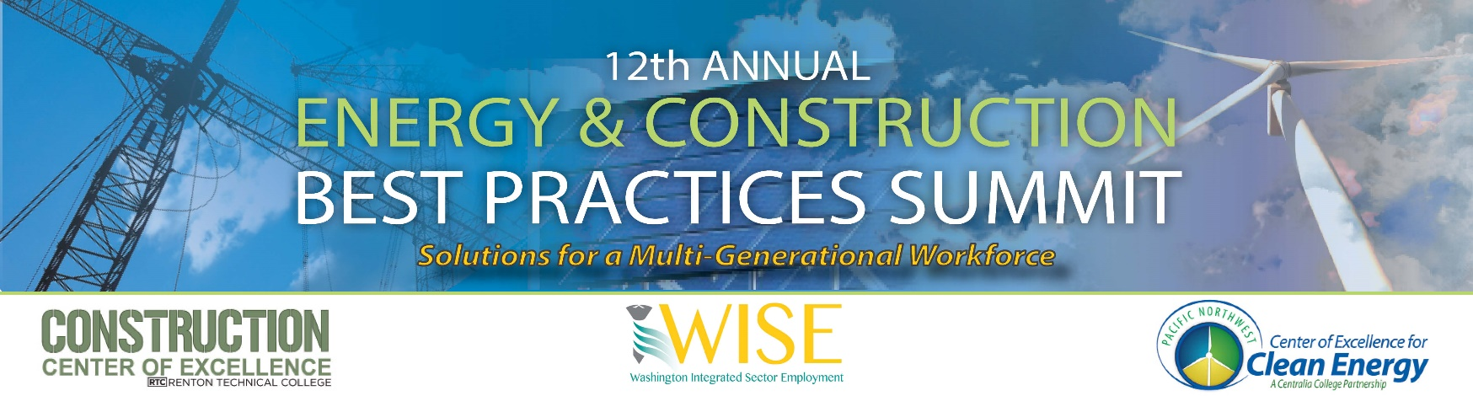

EVENT SPONSOR AND EXHIBITOR INFORMATION

Company Name: ______________________________ Contact Name: _____________________

Phone Number: _______________________ Email: ___________________________________

□ Yes-I want to be a sponsor at the following level:

□ Bronze-$250 □Silver-$500 □Gold-$750 □Platinum-$1,000

□ Yes-I want to be an exhibitor:

Here are my needs for booth space:

_____ Number of tables _____Number of chairs Electrical Outlet □ Yes □ No

Other: ________________________________________________________________________

METHOD OF PAYMENT:
□ Please invoice me
Name: _________________________________________

Company address: _______________________________ City: _______________ State:______
□ Visa
□ MasterCard

_______________________________________________ _____________________
Credit Card # 3-digit security code

_________________________________________________
Authorization Signature
Scan/Email or Mail Form To:
ATTN: James Hovis, Centralia College/Center of Excellence
600 Centralia College Blvd, Centralia WA 98531
james.hovis@centralia.edu

